Interquartile Range (IQR)

To know the outlier range present in the dataset

IQR=Q3-Q1

Lesser Outlier= Q1-1.5*IQR

Greater Outlier=Q3+1.5*IQR

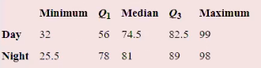

**For Day:**

IQR=Q3-Q1=82.5-56= 26.5

1.5*IQR=1.5*26.5=39.75

Lesser outlier= Q1-1.5*IQR= 56-39.75=16.25

Greater outlier=Q3+1.5*IQR=82.5+39.75=122.25

Hence for the Day, there is no Lesser outlier and Greater outlier while comparing to Min and Max

**For Night:**

IQR=Q3-Q1=89-78= 11

1.5*IQR=1.5*11=16.5

Lesser outlier= Q1-1.5*IQR= 78-16.5=61.5

Greater outlier=Q3+1.5*IQR=89+16.5=105.5

Hence for the Day, there is a Lesser outlier (25.5) and there is no Greater outlier while comparing to Min and Max